**Authoring BIM Bot development**

This document describes the functionality necessary to create a BIM Bot for Authoring applications, based on the work done creating this for Revit.

**Adding a Bot:**

When adding a new bot a GUI is needed showing the available services and setting the trigger and authorization elements. As an example see image below.

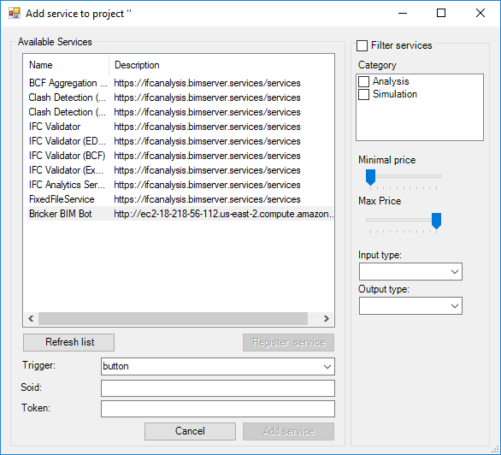

After choosing a Bot, a popup appears with the login window of the Bot (<https://github.com/opensourceBIM/BIM-Bot-services/wiki/Building-a-client-application#32-navigate-to-authorization-url> ). The user authorizes the Revit plugin to use the Bot (user login might be required, depending on the implementation of the Bot).

The list of know Bots is available on github.

The Bot returns a Token that a user must copy-past in the screen.

In this screen the user also decides which trigger (of the authoring tool) should be used to trigger the Bot.

During setup, the authoring tool sends a list of known File formats to the Bot, and the Bot matches it with manageable inputs. Output type is also matched. In practice the input of a Bot is often IFC, and the output is often IFC, JSON, TEXT or BCF.

In some cases the user can choose between a Sync or aSync connection (depending on the level of implementation of the authoring tool).

--

Now the Authoring tool is subscribed to the Bot. Every time the trigger appears, data is send to the Bot, with Token according to the BIM Bot API definition: <https://github.com/opensourceBIM/BIM-Bot-services/wiki/Building-a-client-application#4-calling-the-bimbot>

The result is stored by the Authoring tool.

**Results:**

Another GUI element is needed to show the results of services. An example is shown below:

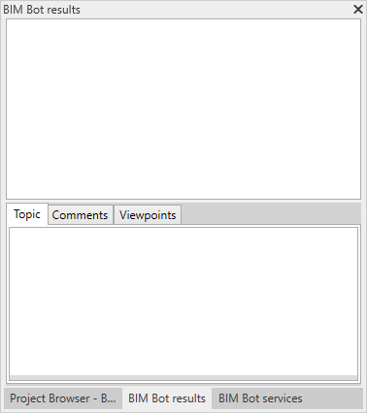

In case of BCF result, a list of BCF topics is shown, with functionalities like zoom-to, filtering, etc.

**Manual triggers:**

A bot can also be manually controlled by the user. Actions could be: trigger the bot, remove the subscription, etc.. As an example see image below.

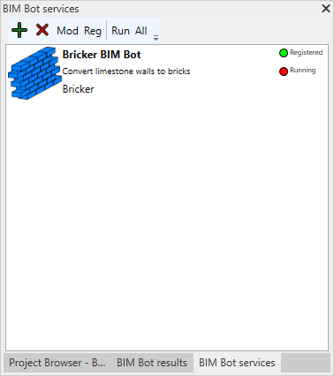

**Demo:**

How this could work in Revit is shown on <https://www.youtube.com/watch?v=CX2F21NFI3A>